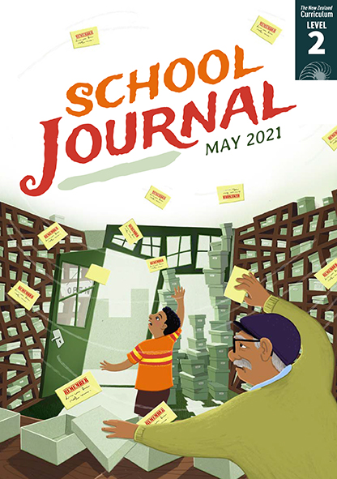

What Do You Remember?
by James Brown
School Journal
Level 2, May 2021
Year 4

The Learning Progression Frameworks (LPFs) describe significant signposts in reading
and writing as students develop and apply their literacy knowledge and skills with increasing expertise from school entry to the end of year 10.

Overview
This poem is a collection of memories – the poet thinking about a number of events in his life, which are presented as a series of vivid images from specific moments that have stuck in his mind. The poem links to “The Memory Toolbox” and “The Memory Bank” in this journal. It shows how the same topic can be approached in different ways. It also provides a model for students’ poetic writing.
A PDF of the text is available at www.schooljournal.tki.org.nz

Themes
- Memory | - Childhood

Related texts
“The Memory Toolbox”, “The Memory Bank” SJ L2 May 2021 | “Come and Meet the Water Whānau” SJ L2 Aug 2020 |
“Our Car” SJ L2 Nov 2019 | “Plastic Planet” SJ L2 Nov 2018 | “My ‘What If’ Planet” SJ L2 Oct 2015 | “Leap” SJ L2 May 2015

Strengthening reading behaviours (what to notice)
Text structure and features | Requiring students to:
- Implied information including the use of metaphor and abstract ideas  my undone shoelace tying my foot to my pedal; his mudguard reversing out of my thigh; Some kid I didn’t know existed even. Maybe that was the reason.  - Some near rhymes that give the poem a rhythm  and flow  line, behind; even, reason; loud, round; sting, in;  thigh, fright; widening, slide; slide, dive, arriving;  thunder, wonder | - visualise the scene, using the context, prior knowledge, and word knowledge to infer the author’s meaning and understand that he has deliberately used unexpected combinations of words to convey strong memories  - identify the rhyming sounds in words and match them to the vowel patterns of letters, noting that not all the words with similar sounds have similar spelling patterns  - understand the purpose of the rhymes

Vocabulary
Some possibly challenging words  and phrases, including some used in unusual ways or contexts | undone, existed, hurling, startled, clover, clash, mudguard, reversing, gashed flesh, widening, defender, oncoming keeper, despairing, boogie board, wrapping, future wonder

Helpful prior knowledge (pre-reading and introducing the text)
- Some small and seemingly inconsequential incidents can become vivid memories.
- People can have very strong memories of particular events.
- Often our memories are linked to the senses.
- Metaphors can link words or phrases to an object that is not normally related.

Possible reading and writing purposes
- Read and enjoy a poem about remembering the past
- Identify what the poet has left to our imagination
- Explore and describe the poet’s use of language
- Describe our responses to the poem.
See Effective Literacy Practice in Years 1–4 for suggestions on using this text with your students (Approaches to teaching reading) and for information about teaching comprehension strategies (Building comprehension and Text processing strategies).

Possible curriculum contexts
This text has links to level 2 of The New Zealand Curriculum in: ENGLISH

Understanding progress
The following aspects of progress are taken from the Learning Progression Frameworks and relate to the specific learning tasks below. See the LPFs for more about how students develop expertise and make progress in these aspects:
- Reading for literary experience
- Making sense of text: reading critically; using knowledge of text structure and features
- Using writing to think and organise for learning
- Creating texts for literary purposes
- Writing meaningful text: using knowledge of text structure and features.

Strengthening understanding through reading and writing
Select from the following suggestions and adapt them according to your students’ strengths, needs, and experiences.
Note: Most of these activities lend themselves to students working in pairs or small groups.
- Have the students read the poem to themselves, taking time to look at the illustrations as they read.
- Ask the students to share their responses. You might prompt them with questions, such as Did you enjoy the poem? How do you think the poet feels about these memories? What memories does this poem trigger for you? What have you noticed about the way the poem is written? What part stands out most for you? You could provide a copy of the poem for the students to highlight and mark up to support them in a class or group discussion.
- Focus on the first verse together, asking the students to share anything they noticed (and marked). They might have noticed close rhymes, patterns, or particular words and phrases. If necessary, draw their attention to any other features, such as rhythm and the way sentences and phrases run over the lines. You could model how the text flows when read aloud. Invite the students to read the poem aloud, individually, in a pair, or with a group. They could record themselves reading aloud and identify and discuss any differences in how they read it.
- Encourage the students to think critically about how the poet has described the memories in each stanza. Some English language learners may need a scaffold to support their understanding of past and future tense. Remind the students about metaphors and point out the unexpected metaphor of the shoelace tying his foot to the pedal. Discuss how the phrase makes it sound as if the event was done to him and how this made it sad. They could then analyse the following verses in pairs. Write up prompts to support the pairs (for example, rhythm, rhyme, unusual words, metaphor). The pairs could share their ideas after each verse or at the end.
- Ask the students to imagine what happened leading up to the moments described in each verse and what might have happened next. Working in small groups, the students could dramatise a verse from the poem. Have them record their ideas on the Inferences template at the end of this TSM. Discuss why these details weren’t included in the poem. Have the students write on the board or on paper any words they don’t know or that are used in a new or unusual way (for example, “the bee’s sting biting in” or the mudguard “reversing out of my thigh”). As a group, look at each of these words and ask the students to explain what their effect is and what the poet is trying to say by using them in this way. Some English language learners may not recognise this text as being unusual. Explore with them how these words are most commonly used.
- The students could create their own “What do I remember?” poem. Ask them to think of six or eight different memories to include and to use the poem as a model (each line starting with “I remember …”).
- Explore how some words in the poem are created and formed, for example, by joining two words together (“mudguard”) or by adding a prefix or suffix (“undone”, “despairing”). Discuss any patterns, the meaning of the prefixes and suffixes, and other words that can be formed in the same way.

“What Do You Remember?” Inferences

Verse | Memory | What happened before? What happened next?  (It could be a good or a bad outcome)
1 | shoelace ties foot to pedal
2
3
4
5
6
7

